Math 8 Application 14 Name ________________________
Show all your work!
1. Circle the letter that represents the approximate location on the number line of $\sqrt{175}$.  A B C D  0 5 10 15 | 2. Write using a negative exponent:  $\frac{1}{81}$ = | 3. Solve for x:  x² = 400
4. Write in standard notation.  5.84 ∙ 10⁻⁴ | 5. Write the sum in scientific notation.  (6.3 ∙ 10³) + (7.1 ∙ 10³) = | 6. Solve for x.  11x – 15 = 12x + 7
7. If the line segment below is translated down 2, left 4, name the coordinates of the endpoints.  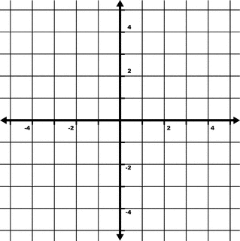 | 8. Find the length of side a below.  4 in. 7 in.  a | 9. Find the measure of angle b.  41◦  b
10. Put the following numbers in order from smallest to largest.  75%, 4/5, .45, 75 | 11. Estimate the product below.  638 ∙ 398 | 12. Write the fraction as a percent. $\frac{3}{4}$
13. Rhonda spent $15 on books for a fundraiser. She makes $2 on each book she sells. Write an equation for the function. | 14. Graph Rhonda’s function.  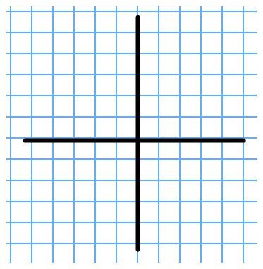 | 15. Complete the table about Rhonda’s function.
  Books sold | Rhonda’s $
  0
  5
  10
  50
16. At Julie’s store, if she increases the price of her product by 35% in order to make a profit, what should she sell a product for that cost her $80? | 17. Find the volume of a sphere that has a diameter of 10 cm. | 18. Sara traveled 486 miles in 9 hours. What was her rate of speed in miles per hour?
19. Juan’s quiz scores are 85, 50, 75, 90, and 100. What is the mean of his quizzes? | 20. James is making award ribbons out of 3 yards of ribbon. If each ribbon takes 8 inches of ribbon, how many ribbons can be make? | Number correct  5 minutes_______  Total___________

